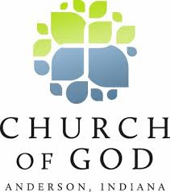

January 4, 2018

Dear Friends,

The Annual State Assembly meeting of the Church of God in Louisiana will be held at 9:00AM on Saturday, March 24th, in Hammond, La at the Pleasant Ridge Church of God, 44291 W Pleasant Ridge Road. This meeting will follow the State Ministers Meeting that will be held Thursday and Friday, March 22-23. ALL MINISTERS on the current approved list of the Credentials are voting members. Also, each congregation is allowed to send ONE LAY DELEGATE as an additional voting member. State Convention this year will follow Friday evening, March 23-24. It is important that you attend this meeting. The meeting will be over at noon and you will be adjourned at that time. Important business will be presented at the assembly meeting, so make plans now to attend.

ALL ministers are strongly encouraged to attend and pray for both of these important events. Please send the NAME of your LAY DELEGATE to the State Office by March 10.

Blessings,

Bro. Steve Nelson, State Coordinator.

Enclosed: Registration Form & Minister’s Meeting Brochure

SN/kde

