1-23-2024

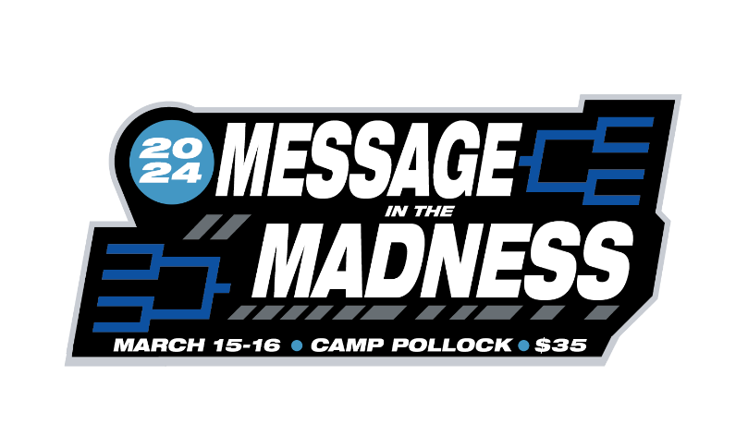

Dear Youth Leader,

Upsets. Crushed Dreams. The Cinderella Story. For just a few days every year we turn our attention to the world of College Basketball for March Madness. We may not know any of the players, colleges, or teams, but it’s always fun selecting brackets and watching the results. (FYI, picking teams based off of mascots isn’t the wisest way to go) One top seed goes down and all the brackets are busted in two hours. But what about when your life plans are disrupted, changed, or some unexpected tragedy leaves you like the upset team? All conflict can lead to God’s glory! This year at Retreat, Lauren Mosher will be leading us to find God’s **Message in the Madness**. Youth Retreat will be March 15 and 16 at Camp Pollock. Registration will be $35 for students and adults. Retreat is a great opportunity for students to renew their camp friendships and make new memories. For new students in your youth group, Retreat is a chance to introduce them to the campgrounds before summer camp! Counselor Training will be on Saturday morning if you have any students wanting to be a counselor this summer. Going through the training doesn’t automatically allow someone to counsel, but it must be completed before qualifying someone for the position. Groups do not need to pay registration before Retreat, but we would like to get our accommodations made before arrival. Please email your current list of students to [rjrials22@live.com](mailto:rjrials22@live.com) by March 13th so we can be prepared for your group. If possible, please bring a male and female counselor for your group. See attachment for logo to use for your promotional materials.

Schedule

Friday

  6           Supper

  730       Session 1

  9           Games/Snacks

Saturday

  815       Breakouts/Counselor Training

  9           Brunch

  930       Group Activity

 1030      Break

 11          Session 2

 12          Dismissal