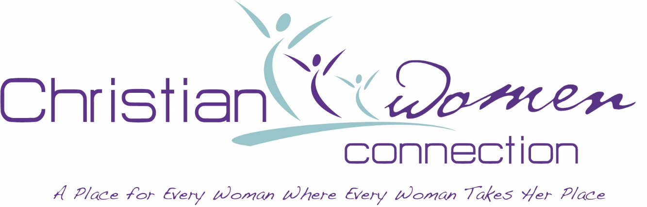
COMING SPRING 2023 . . .
LA CWC State Ministry Event Inviting Ladies of All Ages!
Save the Date: Saturday, May 6, 2023
Theme: “Get Up and Get In . . .”
Scripture: John 5:1-18
Location: Light of the World Comm. Church of God, Shreveport

(STAY TUNED FOR MORE DETAILS)

January 25, 2023

TO: Louisiana State COG-CWC

FROM: Yolanda Chanet
State Finance Coordinator/Treasurer

Greetings to all CWC local and state members and officers:

Due to the changing of State CWC Officers, I Yolanda Chanet have replaced Elaine Richardson as the new Finance Coordinator/Treasurer. All funds that are sent to the state level will now be sent to me at the address below. If you have CBO funds, please send them to me. And if you need to speak to me, I will also include my phone number below.

According to the new changes for the Basic Partnership and Life Time partnership, your Basic Partnership funds of $5/Lifetime of $25 is sent to me, your state Finance Coordinator/Treasurer. Please use the Partnership List stating members name and amount. The list of names should only include persons for that payment at that time. You may send more than one payment due to all person may not pay at the same time.

Funds for the National CWC Basic of $15/Lifetime of $125 can be sent straight to National. If you choose to send it to the state along with your State funds, make sure you indicate that both state funds and national funds are included. If you send more than the State/National fund amounts, please indicate where the overage should go.

All checks that were sent to Elaine back to August 2022 have been passed on to me by Elaine, deposited and documented.

May God continue to Bless You for the work you do in and for Jesus Christ.

Yolanda Chanet, 3351 Fort Meyers Ave, Baton Rouge, La 70814

Phone: 225-571-5693

God Bless,
Yolanda Chanet

