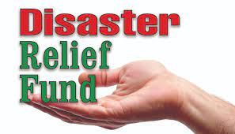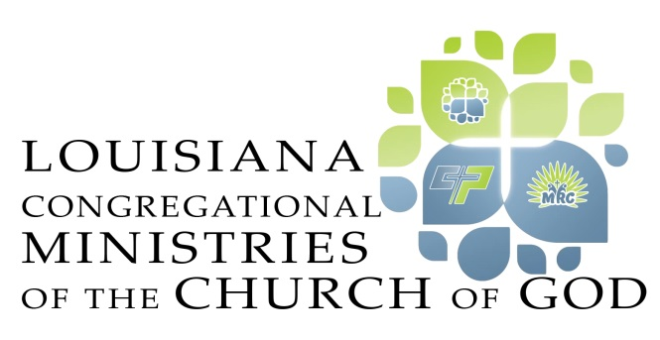

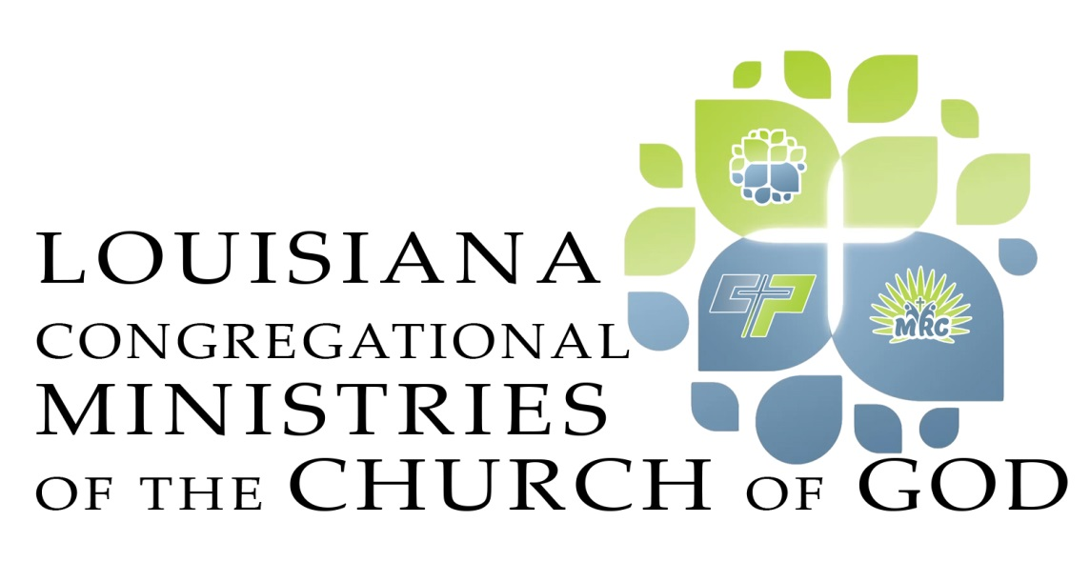

*September 14, 2021*

*Dear Friends,*

*We have almost depleted out State Disaster Relief Funds. I sent $21,000*

*to the churches last week in South Louisiana. I am asking all churches to*

*receive an offering this Sunday or next Sunday to help those in need due to the*

*Hurricanes. Please send your offerings to Ed Ball, CPA, LLC., (our state*

*treasurer) 1000 Chinaberry Drive, Suite 700, Bossier City, LA 71111. Please*

*make your check payable to the LCMCOG and earmark on the memo line*

*Disaster Relief Fund.*

*Thank you and Blessings,*

*Bro. Steve Nelson, State Minister*