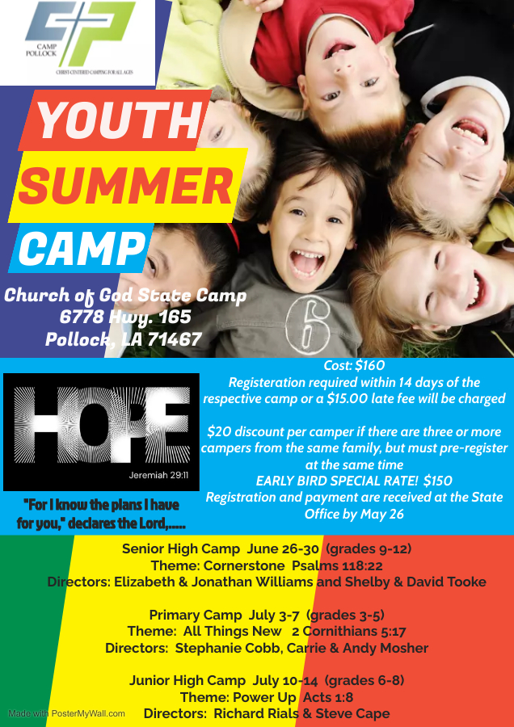
fSSenior High Camp June 26-30 (grades 9-12)
Theme: Under Construction Hebrews 6:12
Directors: Elizabeth & Jonathan Williams, Shelby & David Tooke

Primary Camp July 3-7 (grades 3-5)
Theme: All Things New 2 Corinthians 5:17
Directors: Stephanie Cobb, Carrie & Andy Mosher

Junior High Camp July 10-14 (grades 6-8)
Theme: Power Up Acts 1:8
Directors: Richard Rials & Steve Cape

