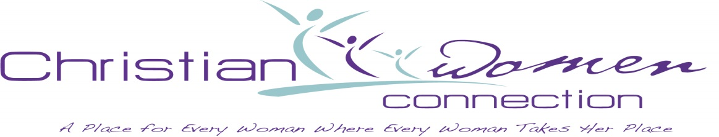

Please mail Christ Birthday Offering or any CWC giving to CWC Treasurer, Elaine Richardson, 12324 Lord Byron Avenue, Baton Rouge, LA 70810. She will send to the National Office with giving by individual churches for recognition from the National Offices.